Layer-controlled Stylolite Growth and the Creation and Destruction of Local Seals
D. Koehn, D. Pataki Rood, N. Beaudoin, J. Aleksans
School of Geographical and Earth Sciences, University of Glasgow, UK; daniel.koehn@glasgow.ac.uk * daniel.koehn@glasgow.ac.uk

ABSTRACT
Cores of carbonate Zechstein sediments in the Lean Gas Field in northern Germany show a dense set of sedimentary stylolites. We studied these structures in detail using scans of cores, thin-sections, roughness analysis, SEM-EDS studies and a set of numerical simulations in order to understand timing and depth of stylolite growth, the development of varying stylolite patterns and their influence on fluid flow. The studied cores have a depth of about 4000m and it is expected that they experienced a minor inversion in the Cretaceous so that their original depth may have been up to 4500m. We studied the roughness of the stylolites and used a stress inversion technique to determine the depth at which they grew. The determined depth of growth is in the order of 4150m with an error of plus-minus 300m. This value represents the latest stylolite activity and indicates that they have been active until late in the burial history. SEM and EDS analysis on stylolite thin sections shows that the stylolites separate strongly dedolomitized sections from sections that still contain a large amount of dolomite. In addition stylolite seams capture or shield dolomitized parts of the rock. Dissolution holes are also partly linked to stylolite teeth indicating that fluid flow is significantly influenced by the presence of stylolites. Stylolite shapes and thus potentially their sealing capacity vary significantly throughout the cores from flat stylolites to small wavy ones all the way to stylolites showing extreme spikes and teeth. Quite often dark layers seem to control stylolite shapes. In order to understand the influence of layers on stylolite growth we use a numerical model that can treat the dynamics of the process linking elasticity with a dissolution routine. In this model we find that layers that dissolve slower can pin stylolite teeth and thus develop extremely long and spiky geometries. Growth typically happens in two to three stages depending on whether or not the pinning layer is destroyed. Stage one represents the nucleation of the stylolite in the layer and its initial growth until it reaches the boundaries of the layer. Typically the initial roughness development leads to a local variation of the position of the stylolite interface with respect to the upper or lower boundary of the layer. Stage two is represented by successive fast growth that is controlled by the pinning layer and the stylolite develops pronounced teeth. Stage three happens in cases where the layer disappears because it is also slowly dissolving. Once the layer is gone stylolite growth basically stops except for local variations in shape and rounding of teeth edges. The developing geometries influence the sealing capacity of stylolites significantly: collection of slow dissolving material in the stylolite does produce a potential seal, offset of a sealing layer due to pinning effects of that layer and the development of teeth can destroy the seal because of leakage across teeth sides and the destruction of a pinning layer due to dissolution destroys the seal completely.

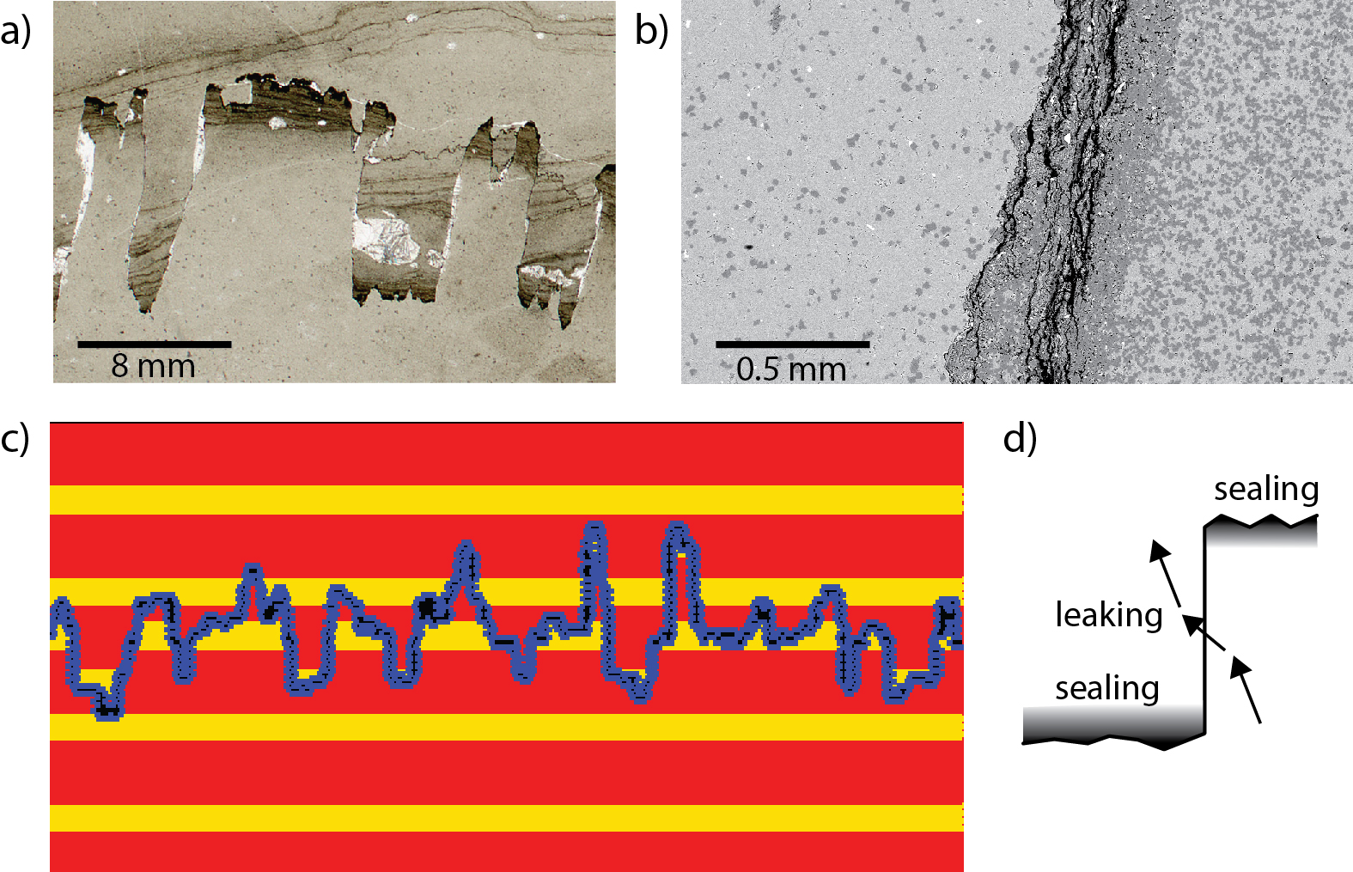

Large stylolite teeth (a) showing layer offsets (potential seals), with tips of teeth influencing reactions (b) where de-dolomitized regions (light grey) are separated from dolomitized regions (dark grey) by stylolites. Modeling (c) shows that layers are offsets and thus seals may leak along flanks of teeth (d).

