Invariantly propagating dissolution fingers in finite-width systems
Filip Dutka* and Piotr Szymczak
Institute of Theoretical Physics, Faculty of Physics, University of Warsaw,
Pasteura 5, 02-093, Warsaw, Poland
* fdutka@fuw.edu.pl

ABSTRACT
Dissolution fingers are formed in porous medium due to positive feedback between transport of reactant and chemical reactions [1-4]. We investigate two-dimensional semi-infinite systems, with constant width $W$ in one direction. In numerical simulations we solve the Darcy flow problem combined with advection-dispersion-reaction equation for the solute transport to track the evolving shapes of the fingers.
We find the stationary, invariantly propagating finger shapes for different widths of the system $W$, flow rates and reaction rates. Shape of the reaction front, turns out to be controlled by two dimensionless numbers – the (width-based) Péclet number $Pe_{W}=\frac{v W}{D ϕ_{0}}$ and Damköhler number $Da_{W}=\frac{ksW}{v}$, where $k$ is the reaction rate, $s$ – specific reactive surface area, $v$ - characteristic flow rate, $D$ – diffusion coefficient of the solute, and $ϕ_{0}$ – initial porosity of the rock matrix. Length of the stationary finger $L$ turns out to be proportional to $Pe_{W}W$. Velocity of propagating front in initial stages of finger formation as a function of system parameters is also calculated.

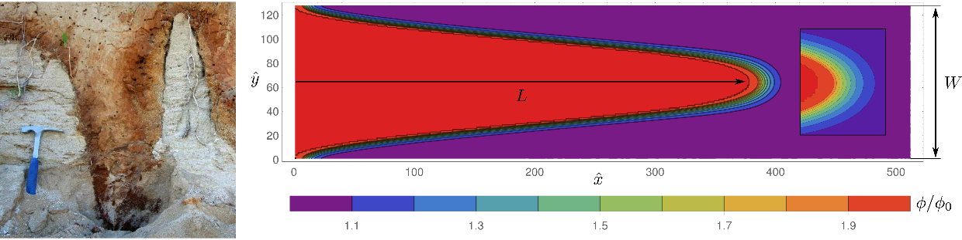
Fig. 1 Dissolution finger in the limestone quarry in Smerdyna (left) and porosity $ϕ/ϕ_{0}$ obtained in simulation for Péclet number $Pe_{W}=128$ and Damköhler number $Da_{W}=25.6$ (right). Inset shows close-up of the dissolution front.
References

- P. Ortoleva, Chadam, J. E., Merino, and A. Sen, Geochemical self-organization II: the reactive-infiltration instability, Am. J. Sci, 287, 1008-1040 (1987).
- M. L. Hoefner, and H. S. Fogler. Pore evolution and channel formation during flow and reaction in porous media, AIChE Journal 34, 45-54 (1988).
- C. E. Cohen, D. Ding, M. Quintard, and B. Bazin, From pore scale to wellbore scale: impact of geometry on wormhole growth in carbonate acidization, Chemical Engineering Science 63, 3088-3099 (2008).
- P. Szymczak and A. J. C. Ladd, Reactive infiltration instabilities in rocks. Dissolution of a porous matrix, J. Fluid Mech. 738, 591-630 (2014)
- 738738dd(2014(2014), pp. 591–630(

